Code Readability of Java Classes
by

Amer M. Kaleemullah

This project is submitted to the Gannon University graduate faculty in
partial fulfillment for the degree Master of Science in Computer and Information Science.
Option: Information Systems

Approved:
Yunkai Liu Ph.D. |  | Mark C. Blair, M.S.
Advising Professor in Charge of Research |  | Committee Member
Mei-Huei Tang, Ph.D. |  | Mei-Huei Tang, Ph.D.
Committee Member |  | Chair, Computer and Information Science Department

Gannon University
Erie, Pennsylvania 16541

MAY 2016

Acknowledgements

First of all, I would like to thank my family because without their immense love and support I would not be here in pursuit of a Masters’ in Computer Science from the prestigious Gannon University.
I also want to thank Dr. Xu for recommending the idea behind the project, without his help and direction I could not have finished this project.
Thank you so much Dr. Liu for helping me on many tasks and issues I was faced with during the course of my final year in Gannon University. Without his guidance and support, the project objective would be a lot harder to accomplish.
Lastly, I need to thank the entire CIS faculty of Gannon University for equipping me with the knowledge required to earn my Master’s degree. It would have been impossible for me to graduate without their expertise.

Table of Contents
Acknowledgements ii
Abstract iv
List of Figures v
List of Tables vi
1. Introduction 1
1.1 Overview 1
1.2 Curriculum Scope 1
1.3 Project Management Plan 2
2. Survey of the Literature 3
2.1 Literature Perspective 3
2.2 Fundamental Literature 4
2.2.1 Readability in Our Research 4
2.2.2 ANTLR 3 6
Another Tool for Language Recognition (ANTLR) is a language tool that provides a framework for constructing recognizers, compilers, and translators from grammatical descriptions containing Java, C++, or C# actions. 6
For this project, ANTLR is used as a parser generator that will handle lexers, parsers, and tree parsers. One of the first things I needed to do with ANTLR is appoint a Java grammar file to class path. A grammar file will be fed any text you want to parse and attempt to recognize, for our purpose, when it encounters a package declaration, class declaration, method declaration, and variables declared in the various .java files that we are going to feed the project in order to generate reports necessary for the proceeding steps in this project. 6
2.3 Literature Summary 6
3. Methodology of Analysis 7
3.1 Introduction 7
3.2 Objective of the Analysis 8
3.3 Methodology Application 9
3.3.1 Readability Calculation 9
3.3.2 Readability Algorithm 16
3.4 Statement of Analysis Scope 17
3.5 Methodology Challenges 18
There are many challenges in this project that came to be known over the course of this project and I will introduce several main challenges I was confronted with in this research. 18
3.5.1 Word Split 18
4. Results of Analysis 19
4.1 Quantitative Analysis 19
5. Conclusion 20
References 22
Appendix D: Design Models 23
Appendix E: Testing Log and Summary Status 26
Appendix F: Screen Captures 26
Appendix G: Project File Repository Definitions 26

Abstract
Multiple readability metrics exist to evaluate the readability of English text but none exists for evaluating the readability of programmer code. In this project, we attempt to program code in Java to read decompiled .java code, using the ANTLR parser tool to generate code reports consisting of important information such as package name, class name, method name, variable type, variable name, variable declaration line number and usage line numbers. These variables were only categorized under methods in which they were defined; so then the readability of each method was the average concreteness of all the variables listed under it.
We used Marc Brysbaert’s readability ratings for approximately 40,000 words, to calculate the concreteness of variables based on their distance of definition and usage and their readability rating. Then we defined class concreteness as the average concreteness of all the methods under that class. The next step was to graph the number of method calls from methods with their direction, i.e. calls made to every method from another method or methods in order to measure the inter-connectivity and magnitude of all the classes of a software code; this was done by implementing another report file which stated every method and the calls made by it and by which method, classified by the class and package it originated from. This data was useful in designing an algorithm, which was used to calculate the concreteness of a whole software code. I devised this algorithm to define readability as the sum of all the products of class magnitudes and class concreteness for every class listed in the software code.

List of Figures

Figure 1. Visitor: Package Declaration Listener……………………………………………………………………………….9
Figure 2. Visitor Tree: Class Declaration Listener………………………………………………………………………… 10
Figure 3. Visitor Tree: Method Declaration Listener……………………………………………………………………. 10
Figure 4. Visitor Tree: Variable Declaration Listener……………………………………………………………………. 11
Figure 5. Java Source Code Report File………………………………………………………………………………………… 11
Figure 6. Java Class to Split Compound Variables………………………………………………………………………….13
Figure 7. Method Readability………………………………………………………………………………………………………. 14
Figure 8. Java Code for Method Caller and Method Callee Visitor……………………………………………….. 15
Figure 9. Satellite Structured Software Calling Graph………………………………………………………………….. 17
Figure 10. Relationship Between Readability and Lines of Code………………………………………………….. 20

List of Tables
Table 1. Selected Open Source Software Codes………………………………………………………………………………7
Table 2. Word Concreteness List………………………………………………………………………………………………… 12
Table 3. Caller & Callee Method Text File……………………………………………………………………………………..16
Table 4. All Applications and Analysis Data…………………………………………………………………………………..19

- Introduction

Overview
Readability is vital for the maintenance and improvement of code. A fairly sufficient amount of research exists about readability [1] [2] [3] [4] [5]. If a programmer can read the code like a book, he can work on the code much faster than if he spends more time tying to figure out viable names and methods [6]. Developers spend the majority of their time editing, removing and adding code to the existing source code. Also, it is much simpler to write new code than to try and understand existing code to find ways to adopt it or repurpose it [7]. When a programmer, irrespective of the level of his skills, can read and comprehend the operation, control flow, and the purpose of a written piece of code is known to have a high Code Readability. This affects many aspects of the lifecycle of a computer program (specifically the source code) such as usability and reusability, portability, and maintainability. Now, software developers can have an idea of how readable a given code just by looking at it. How convenient would it be if a developer has the means to measure the readability of the whole software code?
The objective of this project is to calculate the readability of whole software code (Java) through a series of report generations and calculations. Ultimately, after the calculated numbers have been applied to a readability algorithm, one number will represent this readability.

Curriculum Scope
This project required intensive object oriented Java programming skills. I had to code a series of programs and utilize a parser generator tool called ANTLR to walk through the byte code of a given software code to generate text reports. I wrote another Java program to read these reports since they ranged from a thousand lines to two hundred thousand lines to generate simpler and condensed reports. Ultimately, the results gathered from the reports were applied to my readability algorithm to represent the readability.
To accomplish said tasks, skills acquired from the courses GCIS 512 Object Oriented Modeling, and GCIS 563 Object Oriented Problem Solving helped tremendously with complex programming with a large amount of data. GCIS 564 Data Structures helped me with using Java libraries previously unknown to me to crunch this data. Topics from GCIS 611 Software Project Management aided retaining my progress at a steady rate and kept me from veering off the directed path of project completion.

Project Management Plan
The largest part of this project consisted of writing code and implementing a parser environment that reads code. With the advice and help of Dr. Xu and Dr. Liu, I had to use ANTLR (Another Tool for Language Recognition), which is a powerful parser generator for reading, processing, executing, or translating structured text or binary files. Using ANTLR would have been gravely difficult as it’s quite complex and, if it weren’t for Dr. Xu’s lectures on how to implement the ANTLR environment with Java grammar to use its parser to walk though the code it would’ve taken a lot of time to teach this to myself.
This parser had to be customized to trigger a report line every time it encountered a variable in the code. Each line had to have information on a number of factors; the line numbers the variables are created and used on, the data type of variables, the methods they are defined in, the class in which the method exists and the package from which this method is coming from. To achieve all this, there had to be a set path which was derived from the file tree of a given source code of a whole software. This had to be done with a simple file tree walker.
The next challenge is mainly in the part of analysis and results evaluation, which had to be divided into separate parts for which I had individually code programs that eventually calculated the readability of the whole Java software source code. This includes calculating the concreteness value of variables in order to evaluate the readability of methods, and proper estimation of method calls from the source code.
- Survey of the Literature

Literature Perspective
Readability of the source code has always been an issue in terms of quality of the software source code. Around the 70’s, programmers were realizing the association between readability and code quality. This is evident through the workings of Edsger W. Dijktra, in his book “A Discipline of Programming” [1] where he postulated that readability is an essential characteristic of quality in source code. Early the next decade, specifically 1982, Michael Marcotty and James Elshoff described the dynamics that affect the code readability as being directly related with the familiarity of the programmer looking at the code, coding styles such as consistent structuring and adding comments, and the skill set of the programmer in the application area. They claimed that a program with a low readability most definitely correlates to poor software source code quality [2].
In the 90’s, when the Internet .com fad was booming, programmers and researchers all around the globe started to identify readability or the factors that affect it with a more scientific approach. In 1998, Nuzhat J. Haneef proposed that readability can be identified by four main factors namely, software source code nomenclature, software source code structure style, developer added comments and related documentations, and most importantly software source code complexity [7]. Although no further research has been conducted on this as of yet, two of the aforementioned factors, software source code nomenclature and code complexity, are still factored into the research regarding code readability.
The software source code complexity based readability is evaluated using the structural analysis and the logic behind the source code. This is evident in the study “A Metric for Software Readability” conducted by Raymond P. L. Buse and W. R. Weimer and their team [3]. Using their own definition of readability, they calculated readability of software code based on software features, feature logic, and structure. Their results proved that their definition of readability fit the criteria of human understandability by over 80%. They conducted this on 14 open source software codes, which proved that their theory about readability calculation was quite accurate.
Nomenclature based readability relies upon the names used to identify variables. It is based on how meaningful the name of the variable is and how well does it imply its purpose. Simon Butler along with his team is the most active researcher on this topic, which is exemplified by two papers he published [5] [8]. Him and his team assumed that the identifier names could be directly correlated with measuring code readability and proved that identifier names can and should be factored into code readability calculations.
In the paper “Learning a Metric for Code Readability,” Raymond P. L. Buse and his team conducted a research to define readability with the help of 120 human annotators. After their work on readability lead them to analyze more than 2 million lines of code, they also devised a theory that poor code readability directly correlates with bugs identified by FindBugs [4]. My project only concentrates on readability, and to avoid scope creep and to reduce the complexity of this project, I will not be concentrating on what factors might play a role into affecting readability or how coding bugs might directly correlate to software code readability since this is a whole new topic entirely and a whole other project that was already picked up by one of our students, Han Zhang with his project titled “A Mining Approach for Discovering Association between Source Code Readability and Bugs.” His results were inconclusive and needed more data. Perhaps some one might come along and I hope my project along with Han’s might be useful in the future for further research on this topic.

Fundamental Literature

Readability in Our Research
From what I’ve learned though the very limited amount of research conducted on code readability is that there are two kinds of readability, namely Source structure and Text Readability.
- Source Structure:
  - Source code complexity, graph-based complexity (McCabe’s Complexity)
  - Coding style where the programmers or group of programmers follow a coding style and consistently stick to it through out the life cycle.
  - Halstead complexity measures, i.e. the number of operators and operands.
- Text Readability:
  - Coherence
  - Semantic
Since most of our readability calculations are based upon conducting experiments mostly at the method level, the complexity of the source code is usually simple and more likely related to the content of the method. Hence we can assume for now that the main factors that affect source code readability are code style or format, and code text readability. Code text readability of a method can be said to be directly associated with the variables defined under it; therefore, we should adopt the approach of Marc Brysbaert to use the research result of word concreteness to compute the text readability [10].
It is also safe to assume that all code has equal readability in the IDE part due to the frequent usage of IDE’s such as Eclipse, which forces the user to follow a specific format or structure. As a result, the code structures and formats are usually arranged in a common way in Java source code. Based on our assumptions so far, we used 4 steps to calculate readability: list the English words from variables; compute the word concreteness using Brysbaert’s word rating; use the distance curve to estimate the readability of the methods; calculate the readability of classes based on method calls.

ANTLR 3

Another Tool for Language Recognition (ANTLR) is a language tool that provides a framework for constructing recognizers, compilers, and translators from grammatical descriptions containing Java, C++, or C# actions.

For this project, ANTLR is used as a parser generator that will handle lexers, parsers, and tree parsers. One of the first things I needed to do with ANTLR is appoint a Java grammar file to class path. A grammar file will be fed any text you want to parse and attempt to recognize, for our purpose, when it encounters a package declaration, class declaration, method declaration, and variables declared in the various .java files that we are going to feed the project in order to generate reports necessary for the proceeding steps in this project.

Literature Summary
Based on the information acquired from the research above, we will now conduct the readability calculations on the variables all the way up to the Class level. Each step will be explained in detail along the way as we progress though this report.
- Methodology of Analysis

Introduction
Dr. Xu has provided me with 13 select open source software codes to conduct my readability research. These software’s range from a simple card game to a complex P2P file sharing applet that has about a quarter of a million lines of code. The source files and packages can be found can be found in the “source_code” folder in Appendix B and they are:
Project Name | Version | Description
Junit | 4.4 | Software Development
Jsch | 0.1.51 | Security
Jedit | 4.2 | Text Editor
Jmencode | 0.64 | Video Encoding
jasperReports | 2.0.4 | Dynamic Content
jFreeChart | 1.0.19 | Data Representation
FreeCol | 0.7.3 | Game
ganttProject | 2.7 | Scheduling
Hibernate | 2.1.8 | Database
soapUI | 2.0.1 | Web Service
Xholon | 0.7 | Simulation
Datacrow | 3.4.5 | Data Management
Avuze | 5.5.0.0 | P2P File Sharing

Table 1. Selected Open Source Software Codes

Dr. Xu and Dr. Liu has handpicked these 13 open source software codes because they thought these have covered most categories in open source applications in terms of varying complexity, entire length of code, etc. So the 13 programs are a good example and cover pretty much all of the categories that the open source world of software’s has to offer.
3 main steps are followed in the methodology:
- Generate data reports using ANTLR parser and custom listeners.
- Analyze the reports using Java programs, which I had to code.
  - Measure the concreteness of all variables using the Brysbaert ratings file.
  - Calculate the method readabilities as average concreteness of all variables listed under each method divided by average reading distance, which is found by the difference between the line numbers of variable declaration, and usage, all added up together.
  - Measure the method calls, i.e. evaluate the magnitude at which a method is being called by another method, and the magnitude at which that method calls other methods.
- Gather the data from the previous steps and plug them into a readability algorithm to calculate the readability of the whole Java software source code.

Objective of the Analysis
We suppose that the amount of lines present in the software source code has something to do with its readability rating but this project would be too broad to take that into consideration. So it all boils down to one thing in order to keep the focus of this project at one singular objective:
- Evaluate the readability of the whole software code through its analysis reports though the implementation of a readability algorithm.

Methodology Application

Readability Calculation
There are three main steps to calculate the method readability.
The first step to calculate this readability is to list all the variables in the source code along with its declaration line number and the consequent variable usage line numbers. This step also includes listing the methods the variables are coming from, the classes in which the methods are defined, and the package names in which the classes are defined.
Since this step involved using ANTLR particularly to read through .java files using customized ANTLR java listeners to encounter package declarations, class declarations, method declarations, and variable declarations, it took a significant amount of time to engineer an environment that is fairly new. The following figures are code snippets in the custom Java Listener required for the purpose of this project’s first step:
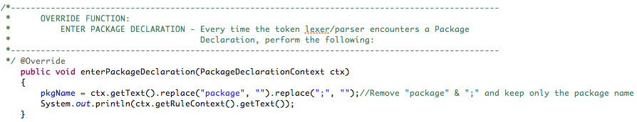
Figure 1. Visitor: Package Declaration Listener
Figure 1 is a custom listener in combination of the rules of the Java programming language listed under the Java.g4 grammar file looks for package declarations though the keyword “package” ending with a semicolon. When it encounters a package declaration, it extracts this text and erases the “package” keyword and the semicolon from the token stream so that only the package name can be inserted into the report text file.
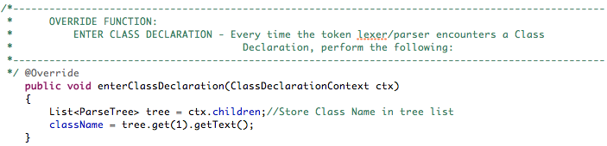
Figure 2. Visitor Tree: Class Declaration Listener
Figure 2 is a custom listener in combination of the rules of the Java programming language listed under the Java.g4 grammar file looks for class declarations though the keyword “Class” and extracts the class name from the token stream for the insertion into the report text file.
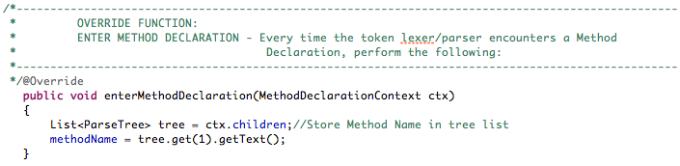
Figure 3. Visitor Tree: Method Declaration Listener
Figure 3 is a custom listener in combination of the rules of the Java programming language listed under the Java.g4 grammar file looks for method declarations once the visitor enters a class declaration and extracts the method name from the token stream for the insertion into the report text file.

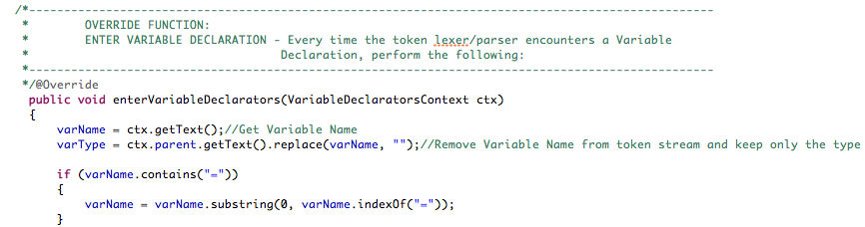
Figure 4. Visitor Tree: Variable Declaration Listener
Figure 4 is a custom listener in combination of the rules of the Java programming language listed under the Java.g4 grammar file looks for variable declarations once the visitor enters a method declaration and extracts the variable name from the token stream for the insertion into the report text file. This listener also identifies the type of the variable by comparing it to the various identifier types listed under the grammar file.
Another task in this step involved listing the variable declaration line numbers and the following variable usage line numbers. I asked Dr. Xu to help me with this so, he programmed a software which can get all the variable names and the lines listed in the method. That software will list every variable in the method and list where it is declared and used. The data Dr. Xu’s software produced thorough the source code processing is shown in the figure 5 below.
PackageName ClassName MethodName VarType VarDeclNameLine# VarUsageAtLine
net.sf.jasperreports.ant JRAntCompileTask ClassField Path src 86 [104, 106, 110, 281]
net.sf.jasperreports.ant JRAntCompileTask ClassField File destdir 87 [290, 290, 295, 341]
net.sf.jasperreports.ant JRAntCompileTask ClassField File tempdir 88 [230, 232, 302, 302]
net.sf.jasperreports.ant JRAntCompileTask ClassField boolean keepjava 89 [235]
net.sf.jasperreports.ant JRAntCompileTask setSrcdir Path srcdir 102 [106, 110]
net.sf.jasperreports.ant JRAntCompileTask setDestdir File destdir 136 [138, 138]

Figure 5. Java Source Code Report File
The proceeding steps to calculate readability are all done by another software I programmed. It can be found under the folder “ConcCalculator” in Appendix B.
The second step is to calculate the word concreteness of the names of the variables. The word concreteness calculation would not be possible if it was not for the research conducted by Marc Brysbaert [10]. In 2014, him and his team conducted this research to get concreteness of some 37,058 English words or lemmas and 2,896 two-word expressions. He constructed a list to show all the concreteness of these lemmas though a rating that’s based on a scale of 0 to 5, where 0 being the hardest to comprehend the purpose of the variable and 5 meaning easiest to comprehend the purpose of the variable. Table 2 is a screen capture of the concreteness list which is available in a excel sheet.
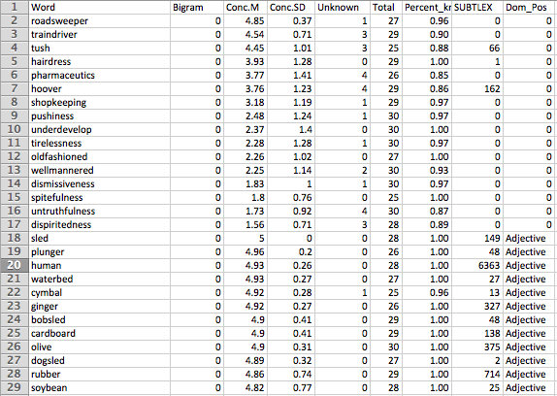
Table 2. Word Concreteness List
In the figure above, the column “Conc.M” is the average, or “M” for mean, concreteness rating rated by English annotators represented through the column “Total”. The column “Conc.SD” is the standard deviation of the concreteness ratings. The column “Unknown” signifies the number of annotators, which did not know the word, and the column signified by “Percent” is the percentage of participants who recognized the word.
In this project, I used the “Conc.M” as the concreteness of the word. The Java program I coded to calculate the readability of methods involved matching the variable names from figure 5 to this list in figure 6 to get the concreteness of each variable. If the program does not find a word in this list, we can consider it as either being a word that is rarely used, or is a single character, or is just a make-up of the software programmer. We can consider that such situations are hard for people to comprehend, so we are going to mark the concreteness of such variables as being zero. For instance, variables identified by “i”, “j”, “sw”, “br” will be assigned a value of 0 for their concreteness since people will not understand the purpose of the variable or what it is used for just based on its name.
Situations arise for compound variables such as “NumOfEmployees”, which won’t be present on the concreteness list. To tackle this issue of compound variable names, I coded the logic to split the compound variables into several parts based on camel notation or underscores “_”, etc. and calculate the concreteness of every split word and compute the concreteness of the compound variable as the average of all the words. For example, we can split the word “valueName” into “value” and “name”. Then we can find in the concreteness list that the value of “value” is 1.62 and “name” has a concreteness of 3.5, then we can compute that the concreteness of “valueName” is 2.56. A code snippet is provided in figure 6.
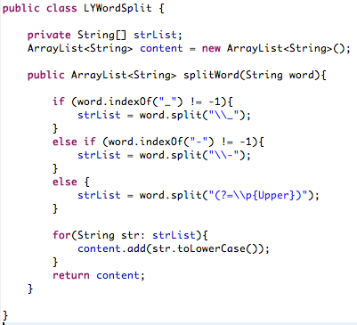
Figure 6. Java Class to Split Compound Variables
The proceeding task in this step is to calculate the readability reduction caused by the distance between declaration and use of the variables. For this purpose, I have programmed a Java code which reads the distance of the variable v at line i, denoted by the method name dist(v, l, i), which is defined as the line difference of the declaration of the variable v at line l and the usage of v at line i. then the reading distance of the variable v is the sum of dist(v, l, i) where i is the collective usages of v at the line I declared at line l. Then the readability of a variable v, or read(v), is defined as concreteness(v)/dist(v, l, i). Therefore, the readability of a method m, read(m), is defined as the average of avg(read(V)), where V is the set of all the variables declared in the method m. A code snippet of this representation is shown below in figure 7.
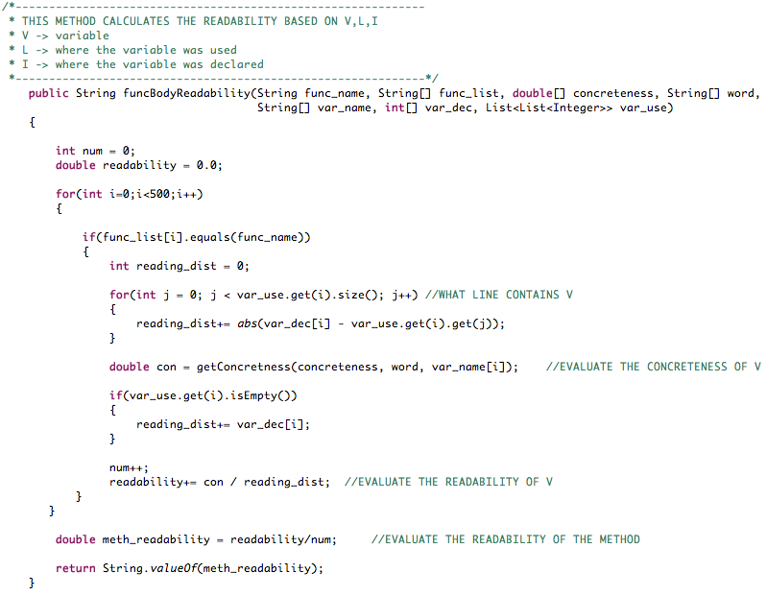
Figure 7. Method Readability

The final task in this step is to calculate the method calls from every class present in all of the 13 open source software code. For this task, I used the help of the Java library called Japa Parser. There wasn’t much documentation on how to use this library but I found an online tutorial (https://code.google.com/archive/p/javaparser/wikis/UsingThisParser.wiki) on how to implement this library in order to visit classes and methods. At first, I successfully wrote the code to print out the results of the Caller method and the Callee method but there was a slight issue with how I was storing the Callee methods where I was using a list to store them. The problem was that the list could only hold one Callee method and per caller method, and it would only store the last one as the method caller visitor progressed through the byte code of the Java files. So to overcome this, I used the collection type Set to store all the Callee methods per Caller method. Below is the code snippet I used to accomplish this task and just below that is an example of how the format of the resulting file looks like.
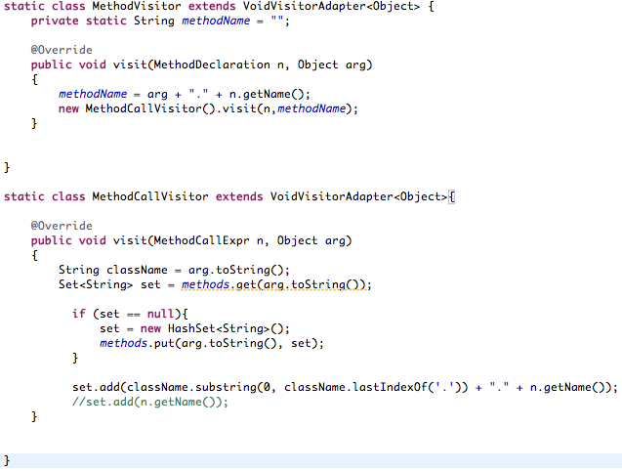
Figure 8. Java Code for Method Caller and Method Callee Visitor
Caller method | Callee method
Package, class,method1 | Package, class,method2
Package, class,method1 | Package, class,method3
… | …

Table 3. Caller & Callee Method Text File
The Callee methods can have the same method names across different classes, so we must go the extra mile to indicate which class and package each and every method is originating from. Using this resulting file, I can gather important data for the final proceeding step, which is the actual readability rating of the whole Java software source code by implementing a readability algorithm, based on the connectivity of the methods.

Readability Algorithm
With the help of Dr. Liu, I was able to formulate a readability algorithm for the whole Java Software source code. This algorithm uses the connectivity text file (the Caller and Callee Methods text file) in order to figure out the magnitude and direction of the methods being called by this method and the magnitude of how many times that method is called by other methods. This calculation would also give me the total number of class connectivity’s, which is nothing but the number of all the Callers and Callee methods added up.
$${Readability= W}_{A}C_{A}+ W_{B}C_{B}+ W_{C}C_{C}+…+W_{n}C_{n}$$
$$W_{n}=\frac{\left(All calls in+All calls out\right) of method}{\sum{(All calls of class)}}$$
$$C_{n}=Concreteness of Class$$
$$W_{n}=Connectivity of the Class$$
In this algorithm, the readability of a Java software source code is defined as the collective sum of all the products of each class connectivity with the Class readability rating. The class readability rating is nothing but the average method readability of all the methods defined under that class. Here, W stands for the connectivity of each class So this algorithm will give out a higher readability rating when there are more methods with most connectivity’s for the whole Java software source code sine the numerator Of W_{n} is directly dependent on the number of calls going in and number of calls going out from the class.
For example, lets take a look at a simple code out of 3 codes I used to demonstrate the implementation of my algorithm. The calling graph of the code is given below in figure 9, which is based around a Satellite class structure. Right below the figure is the readability calculation of classSatellite based on its connectivity and the class readability numbers.
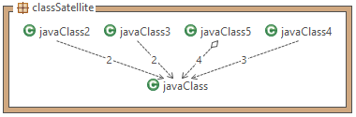
Figure 9. Satellite Structured Software Calling Graph
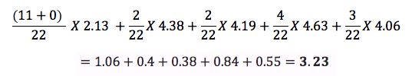

Statement of Analysis Scope
During the course of this project, I learnt that there are several limits in this research:
- The program I coded cannot process big projects, so we can only chose the projects smaller than 30MB
- When we matched the words to the concreteness list, some words could not be matched because it was shortened version of the word or modified for ease of typing. So this time we considered all the unidentified words to have a concreteness of 0, which would not be very accurate.

Methodology Challenges

There are many challenges in this project that came to be known over the course of this project and I will introduce several main challenges I was confronted with in this research.

Word Split
During the process of method readability, the second step was to do with matching the variable names in the source code to the concreteness list we had already had. Since people always combine several words into one word (compound variables), this time we needed to split it.
It was a really challenging task since programmers always combine words in different styles. Some like to use symbols such as a hyphen “-“ or an underscore “_” to join the words. Some use camel notation where they only use the uppercase letter to show a beginning of a word such as “valueName”. These compound variables are not hard to split. However, some programmers just combine the words together with no symbol or camel notation, which is tough to split based on words alone.
In my code to split variables, we can only split the compound variables, which end with common words such as “in”, “out”, “on”, “off”. But when programmers combine words such as “whitehouserepresentative”, I still do not have any method to solve it. This has to do with implementing Natural Language Processing (NLP) to read and identify individual words from compound variables but to keep the scope of this project narrowed down to one objective, I will be limited in such regards.
- Results of Analysis

Quantitative Analysis
Project Name | Description | Readability | Lines of Code x 1000
Avuze | P2P File Share | 1.996 | 201.994
Xholon | Simulator | 1.831 | 21.288
soapUI | Web App | 2.293 | 30.367
datacrow | Data Manager | 1.897 | 19.548
Freecol | Game | 2.208 | 29.751
jasperreports | Dynamic Content | 2.596 | 33.403
Jmencode | Video Encoder | 0.799 | 1.658
Jedit | Text Editor | 1.923 | 35.602
Jsch | Security | 1.583 | 9.44
Junit | Software Testing | 2.056 | 0.996
ganttproject | Scheduling | 1.932 | 30.096

Table 4. All Applications and Analysis Data

After we have processed all the source code in the selected applications by the methodology above, we can get the results as shown in table 4 above. From the results obtained in this project, we can say by glancing at the data that, there is no real association between the sheer length of the code and it’s readability.

Figure 10. Relationship Between Readability and Lines of Code

One thing I feel is important to mention in this report is that I observed that the readability ratings were with in +/- 0.5 points off from the average readability of all the methods listed under a class.
- Conclusion
Based on the result above, and comparing it with the average readabilities of all the methods we can say that the readability is highly dependent on encapsulation, i.e. the way the code structure is implemented may affect the readability and not how many lines of code exists in the Java software source code.
In conclusion, I was able to successfully implement the readability algorithm to figure out the readability of the whole Java software source code. But I can’t say for sure that the ratings are the real ratings of the software code since my research has the aforementioned limitations and I did not have any extra data to compare my analysis with. Perhaps in the future, someone else can further research on this and use the data that I acquired from my analysis to prove if my algorithm indeed is accurate. But I can state by comparing the readabilities of every software source code that, they are quite representative of the average readabilities of the software source codes.
Since the report files are averaging about 100+ lines, it would take up a lot of space to include them inthis report so I have attached the files in Appendix B under the folder Graduate Research Project.

References
[1] E. W. Dijkstra, A Discipline of Programming, Upper Saddle River, NJ: Pentice Hall PTR, 1997.
[2] J. L. Elshoff and M. Marcotty, “Improving computer program readability to aid modification,” Communications of the ACM, vol. v.25 n.8, pp. 512-521, Aug. 1982
[3] R. P. Buse and W. R. Weimer. A metric for software readability. In Proc. Int’l Symp. on Software Testing and Analysis, pages 121–130. ACM, 2008
[4] R. P. Buse and W. Weimer, “Learning a Metric for Code Readability,” Software Engineering IEEE Transactions, vol. 36, no.4, pp. 546-558, July-Aug 2010.
[5] S. Butler, “The effect of identifier naming on source code readability and quality.,” in esec/fse Doctoral Symposium ’09, 2009.
[6] Bergmann, S., & Priebsch, S. (2011). Real-world solutions for developing high-quality PHP frameworks and applications. Indianapolis, Ind.: Wiley Pub.
[7] Nakashian, A. (2011, March 1). Why Code Readability Matters. Retrieved from http://blog.ashodnakashian.com/2011/03/code-readability/
[8] N. J. Haneef, “Software documentation and readability: A proposed process improvement,” ACM SIGSOFT Software Engineering Notes, vol. v.23 n.23, pp. 75-77, May 1998.
[9] S. Butler, M. Wermelinger, Y. Yu and H. Sharp, “Relating Identifier Naming Flaws and Code Quality: an empirical study,” in Working Conference on Reverse Engineering, 2009 16th.
[10] M. Brysbaert, A. B. Warriner and V. Kuperman, “Concreteness ratings for 40 thousand generally known English word lemmas,” Behavior Research Methods, Vol. 46, Issue 3, pp 904-911, Sept. 2014.

Appendix D: Design Models

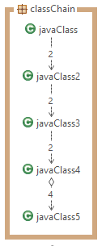

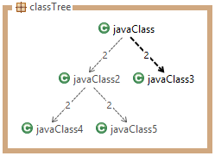

Appendix E: ANTLR3 Setup Instructions

In order to make use of the ANTLR Lexer/Parser Environment for your peroject first you need to get an IDE such as Eclipse or NetBeans. For this Prject I have used Eclipse Standard SDK Service Edition: KEPLER.
- Install Eclipse IDE and setup your workspace.
- Click on the Help menu and click on Install New Software: 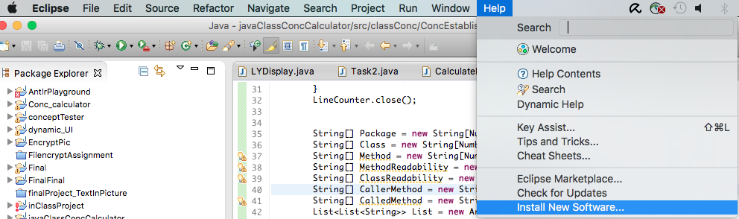
- When you see this Install New Software window show up, click on Add…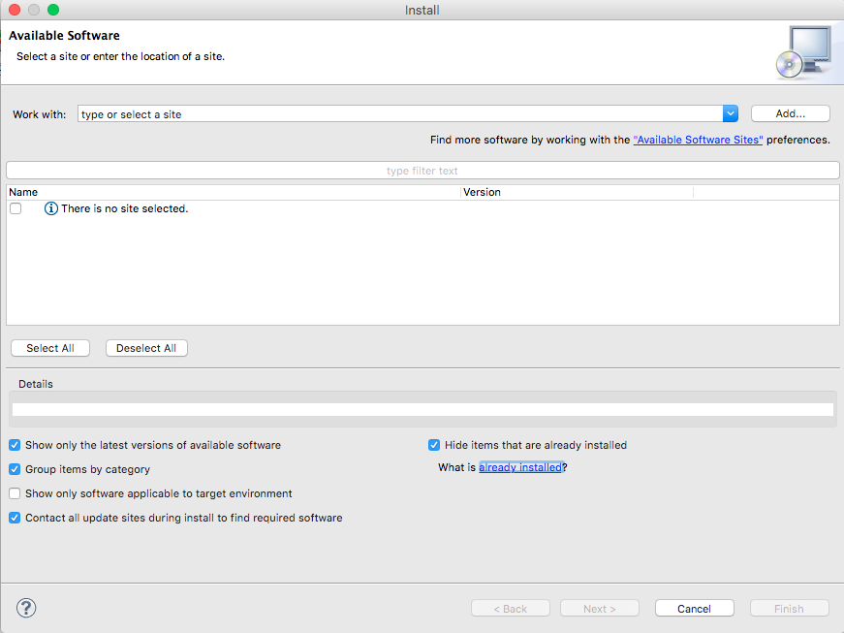
- Then an Add Repository window will show up. Please fill in the text boxes will the following information from the screen capture:

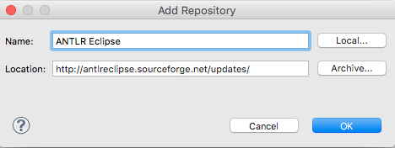
- After filling up the boxes click OK and select the version you want to install. I used version 3.
- Accept the license agreement and press next. Click Finish.
- Eclipse may ask you if you want to restart. I recommend that you do.
- To add/remove the ANTLR project nature to/from a project select a project in Eclipse’s Navigator view and select from the context menu, Toggle ANTLR Project Nature. 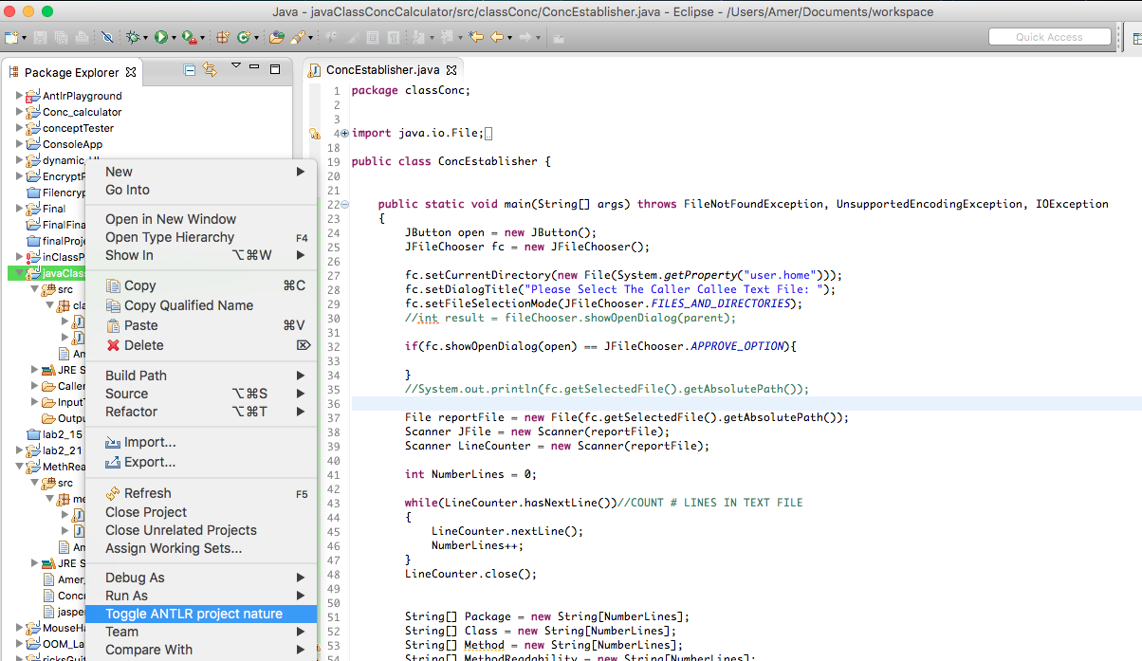
- When you build your project, the ANTLR builder will be executed. If you have automatic build turned on, ANTLR will be run against your grammar file whenever it has been modified.

